Attention 5th Grade Parents!!
FORM due by 4/18!
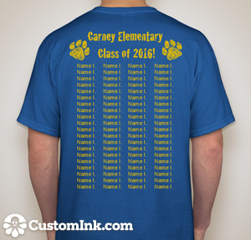
The 5th Grade students all voted on their favorite T-shirt design, and this was the winning design!!! The PTA will be purchasing the shirts for the students, however, parents can opt to also purchase a shirt. The cost is $7.50 per adult (2XL and 3XL, additional $1).
Shirt is ROYAL BLUE
Font is GOLD

Please indicate the size of shirt for your student, and the name that you would like on the shirt. It is First Name Last Initial (Johnny A.).
Please return this form NO LATER than Mon. 4/18! If you are ordering any additional shirts, please remit payment and size by 4/18 as well. Checks are to be made payable to Carney PTA. Please email with any questions at info@carneypta.org.

Student Name: Teacher:
Circle ONE
Youth sizes
Adult sizes
Student T-Shirt Size: YS YM YL YXL AS AM AL AXL A2XL A3XL
Name to appear on back of shirt. (please write legibly!)
Additional shirt order $7.50ea: Qty. Size: Total due(if 2XL or 3XL, add $1)
Form MUST be submitted no later than Friday, 4/18. Shirt orders will not be accepted after 4/18. There is NO CHARGE for the students’ shirts. Payment is only required for any additional shirts being ordered (parents, grandparents, etc.) Thank you!!

