The Carney Cougar “Fun Run”!!

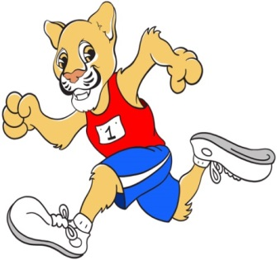
“Fun Run” schedule:
9:45 – 10:25: 4th and 5th grades
10:40 – 11:20: PreK, 1st and 2nd Grades,
& Primary and Intermediate CALS
11:45 – 12:25: Kindergarten, 3rd Grade and K-CALS
Come out and watch your children walk or jog during our Carney Cougar Fun Run on Friday, November 6, 2015 on the upper fields at Carney Elementary School. The purpose of the Fun Run, besides enjoying a healthy and fun day of walking or jogging is to raise funds for the programs and activities of our PTA, as well as other essential educational needs of Carney Elementary School. The PTA provides assemblies, literacy events, teacher appreciation, and much more to Carney Elementary. We hope that you can join us for the Fun Run.
We will also be welcoming the Parkville YMCA on site to participate in our fun event. They will have representatives on site to not only help motivate our students in the Fun Run but to also answer any questions related to healthy lifestyles and the YMCA.

Rain Date Info: The Carney Cougar Fun Run rain date is THURSDAY 11/12. Please note that this is a correction to the originally announced date. Decisions on this will be made and communicated via Facebook and at www.carneypta.org the morning of the event. Please do not call the school.
Raptor Info: All visitors, prior to attending the event on the field, must check in at the office with I.D. and obtain a visitor’s badge before being allowed to join the students.

Please note that it is not too late to donate for the Carney Cougar Fun Run! Donations will continue to be accepted up until Fun Run day. Send in your donations to Carney Elementary PTA or donate online anytime with a credit card at www.carneypta.org. Thank you for your support!!

